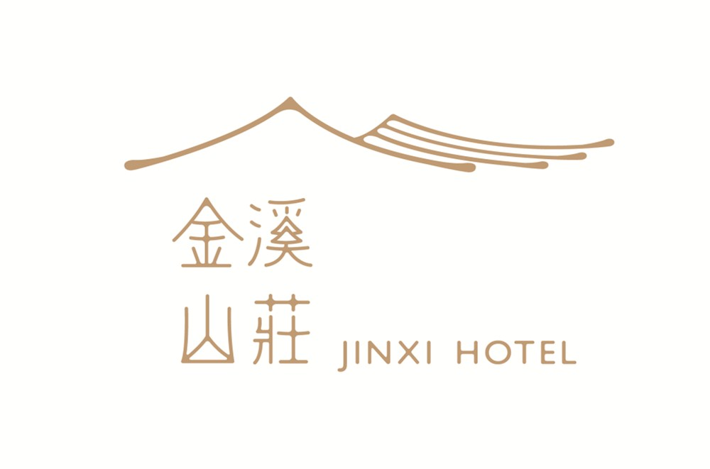会议酒店预订书
Room Reservation for RTCSA 2019/NVMSA 2019

There are two rates for the conference hotel rooms. One is the standard room at 650RMB/night. The other is luxury room at 850RMB/night. Please fill in the following form and send back to jiazhang@zju.edu.cn (Jia Zhang) for hotel room reservation. Once confirmed, hotel staffs will send a confirmation email to the guest.

GUEST NAME
客人姓名
GUEST EMAIL
电子邮件
ARRIVAL DATE  抵店时间 |  | DEPARTURE DATE  离店时间
ROOM TYPE  房 间 | Standard Room (650RMB/night)  or  Luxury Room (850RMB/night) | ROOM RATE  房 价 | 650RMB/850RMB
PERSONS  人 数 |  | PAYMENT METHOD  付款方式 | PAY IN CASH OR CREDIT CARD
REMARKS  备 注 | Room rate includes breakfast.  房价包含早餐费用
如果您还有任何疑问，请随时与我们联系。
If you have any questions, please contact us. Thanks!
地址：中国杭州市杨公堤39号 ADD:NO.39 Yang Causeway, Hangzhou, China
电话Tel： ＋86-571-87992288-88 传真Fax： ＋86-571-87980888

